**Experiment No:** 08

**Experiment Name:** Implementation of Banker's Algorithm

**Aim and Objectives:** Learn about Bankers algorithm. Implement Bankers algorithm by using c program. And testing the program different input and find output .

**Bankers algorithm:**

The Banker's algorithm, sometimes referred to as the avoidance algorithm, is a resource allocation and deadlock avoidance algorithm developed by Edsger Dijkstra that tests for safety by simulating the allocation of predetermined maximum possible amounts of all resources, and then makes an "s-state" check to test for possible deadlock conditions for all other pending activities, before deciding whether allocation should be allowed to continue.

**CODE:**

#include<stdio.h>

int main()

{

int Allocation[100][100],max[100][100],

Available[100],NeedMatrix[100][100],i,j,k=0,

order[100],n,m,count=0;

int finish[100]={0};

printf("Enter Number of process:");

scanf("%d",&n);

printf("\nEnter Number of Resources:");

scanf("%d",&m);

printf("\nEnter Allocation Matrix:\n");

for(i=0;i<n;i++)

for(j=0;j<m;j++)

scanf("%d",&Allocation[i][j]);

printf("\nEnter Max Allocation Matrix:\n");

for(i=0;i<n;i++)

for(j=0;j<m;j++)

scanf("%d",&max[i][j]);

printf("\nEnter Available:\n");

for(j=0;j<m;j++)

scanf("%d",&Available[j]);

printf("\n\nNeed Matrix is:\n");

for(i=0;i<n;i++)

{

for(j=0;j<m;j++){

NeedMatrix[i][j]=max[i][j]-Allocation[i][j];

printf("%d ",NeedMatrix[i][j]);

}

printf("\n");

}

begin:

for(i=0;i<n;i++){

count=0;

if(finish[i]==0){

for(j=0;j<m;j++){

if(Available[j]>=NeedMatrix[i][j])

count++;

else

break;

}

if(count==m){

finish[i]=1;

for(j=0;j<m;j++){

Available[j]=Available[j]+Allocation[i][j];

}

order[k++]=i;

}

}

}

for(i=0;i<n;i++)

{if(finish[i]==0)

goto begin;

}

printf("\n\nSequence is:\n\n");

for(i=0;i<n;i++){

printf("p%d",order[i]);

if(i<n-1)

printf("->");

}

printf("\n\n");

return 0;

}

**Output:**

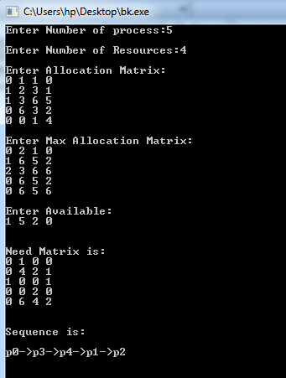

**Discussion:**

After doing this labreport we learn about Bankers algorithm. We also learn how to implement Bankers algorithm by using C program And testing the program different input and find output.